MARINE LICENCE 00010302 - KALY GROUP LTD
SEAWEED FARM, WEST SIDE LOCH BAY, LOCH DUNVEGAN, SKYE
LICENCE CONDITION 3.2.2 – NOTICE OF DEPLOYMENT – RYA

Kaly Group Ltd have been granted a Marine Licence (00010302) for a seaweed farm at Loch Bay, NW Skye.

Under the Licence conditions, Kaly are required to give notice ahead of commencing each phase of development. Kaly intends to deploy a trial Longline rig at the site, along with 2 x Special Marks (Y Fl5 2m) from 07.02.24, weather pending. Please see the co-ordinates, a plan and a diagram of the structure below.

57°30.460'N, 6°37.435'W – special mark west end
57°30.635'N, 6°36.895'W – special mark middle (east end for now)

A38) 57°30.440'N, 6°37.410'W - 1st weight
A41) 57°30.365'N, 6°37.320'W - 2nd weight

Site Plan
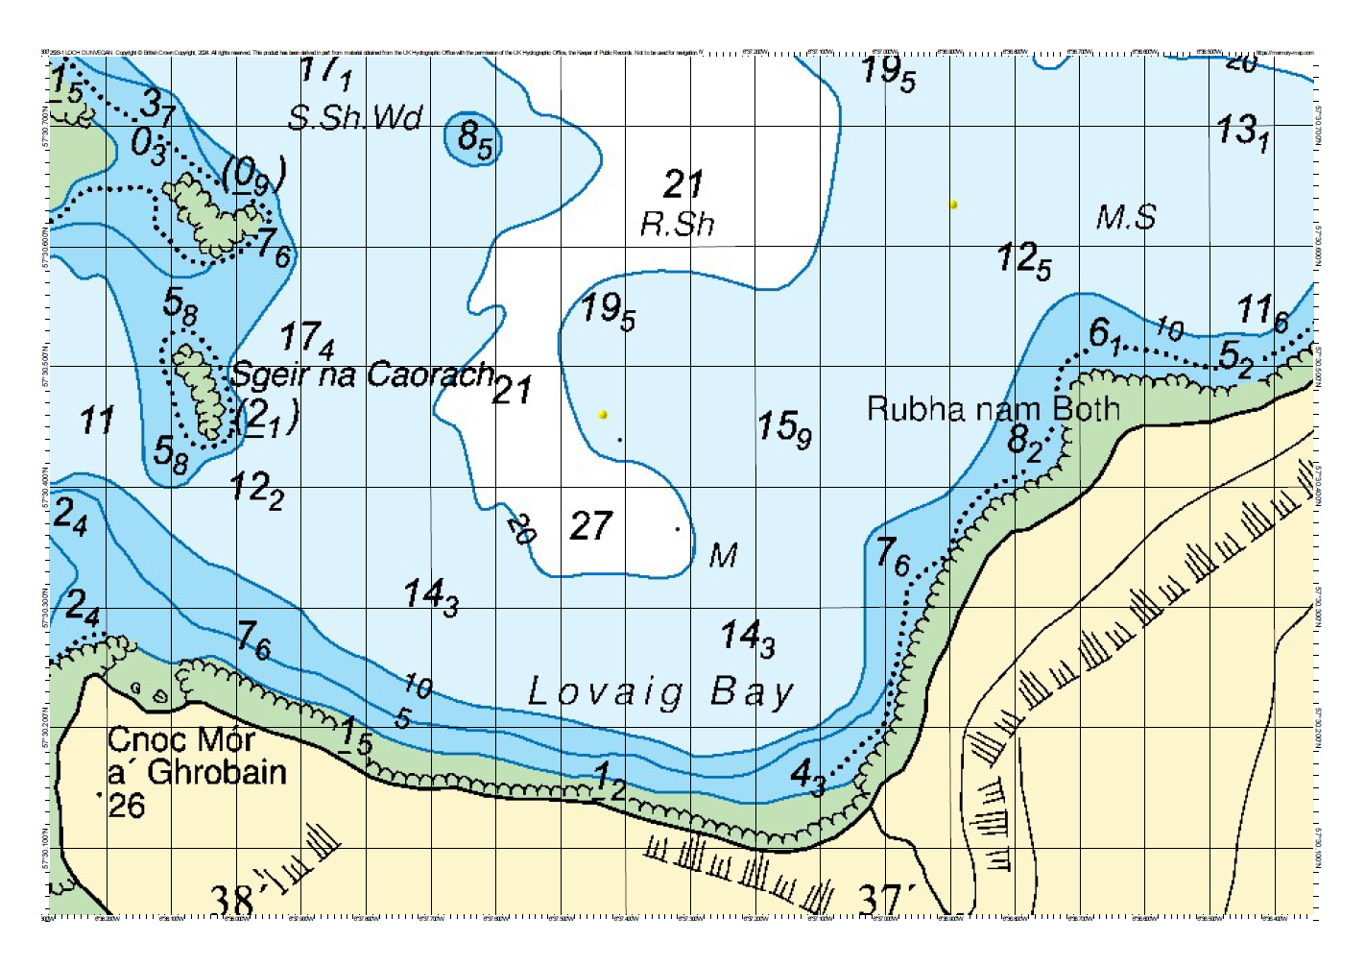

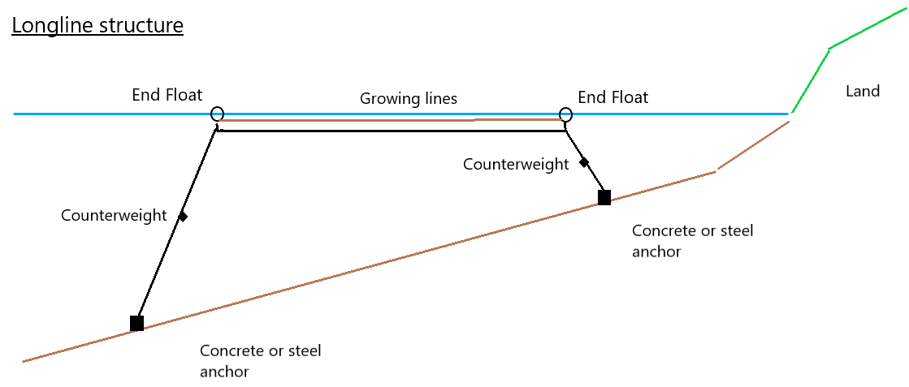
The brown growing line in the diagram above will be deployed from the boat, while the black structural line underneath it in the diagram, will be removed. The brown and black lines will not exist in the water at the same time, so no interactions between them will exist.

